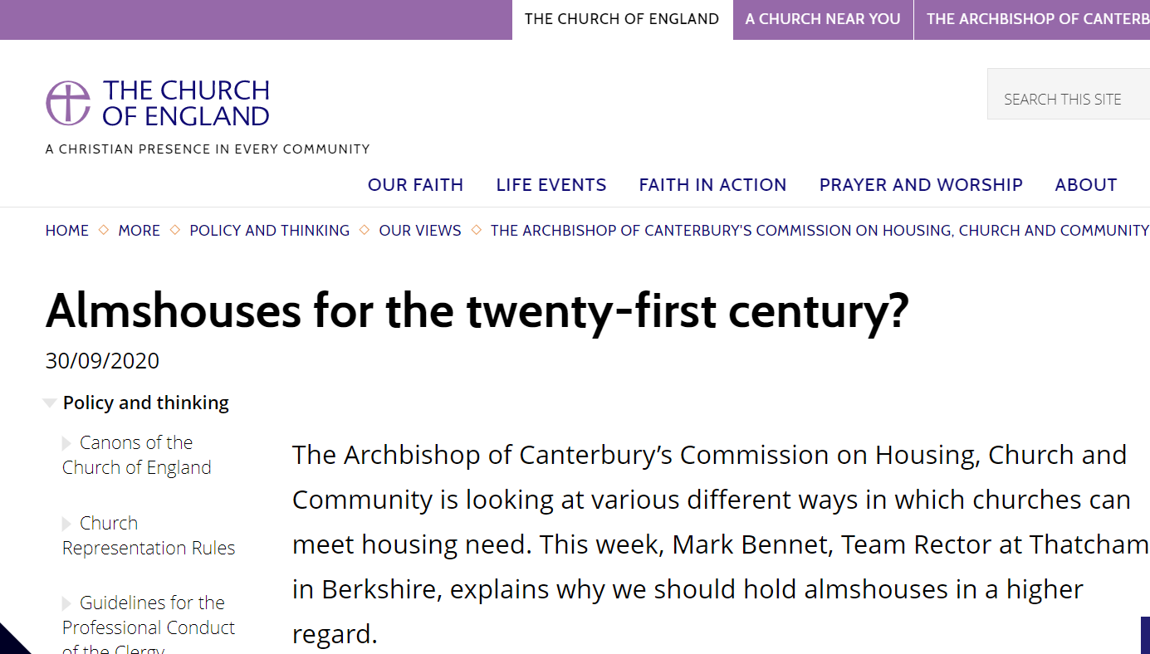

Almshouses for the twenty-first century?
30/09/2020
The Archbishop of Canterbury’s Commission on Housing, Church and Community is looking at various different ways in which churches can meet housing need. This week, Mark Bennet, Team Rector at Thatcham in Berkshire, explains why we should hold almshouses in a higher regard.
Almshouses in Berkshire which look much like any twentieth-century houses, including a small well-kept shared garden.
Before I became a trustee of the Thatcham Parochial Almshouse Charity, the most I had known about Almshouses was from Trollope’s “The Warden” as seen on TV and a vague sense that Almshouses were an antiquated form of do-goodery providing congenial accommodation for distressed gentlefolk and retired clergy. I was to discover that such a view of Almshouses is a profound mistake.
When I became Rector of my parish, I found myself one of nine trustees of Loundye’s and John Hunt’s Almshouses and the quaintly named “Nine Shilling House”. I read the history of the Almshouses – the charity had once owned a field on which grazed a cow, whose milk was provided free to the Almshouse residents. It seemed that my prejudices were being confirmed.
And then I met the residents of our fourteen flats – elderly people (age 55+) in housing need who have been living in the ancient parish of Thatcham. And I found that the Almshouses were providing affordable accommodation for people who might otherwise have fallen through the housing net. The flats are not large, but they are well-maintained with modern amenities (the charity now provides free broadband for residents).
Many of our residents are quite ordinary people who have had a slice of bad luck which could have left them homeless. Some were living with relatives whose circumstances changed – one was living with a son who moved overseas, for example. Others were losing their home as a fall-out from death or divorce in the family. And sometimes a long-standing tenancy is brought unexpectedly to an end – perhaps because of changes in the landlord’s circumstances, or because loss of a job means it has become unaffordable. Unfortunately, people who are at risk of becoming homeless in these ways and who are not at the top of the council’s priority list are unable to find suitable housing at short notice. We do our best to provide them with a home.

When I stepped back from all this, I suddenly realised that the Almshouses in Thatcham had been providing affordable housing for local people for over five hundred years. The first Almshouse was given in 1446, when Thatcham was a much smaller and very different place. Those first Almshouses were the only social housing in a small community and would have had a much greater proportionate impact than they do today.
So what are the features of Almshouses which have contributed to this long-term sustainability? The Almshouses are owned by a charity whose central purpose is the welfare of the residents, subject only to making provision for the long-term sustainability of the charity. This creates an ethos which demands the maintenance of high standards and has been able to keep buildings in good condition. The residents are not technically tenants, but instead beneficiaries of the charity. Residents do not pay “rent” but rather a “weekly maintenance contribution” plus a contribution to heating and lighting costs. These are set below the level of housing benefit which can be claimed by qualifying residents, making them genuinely affordable to people on low incomes (unlike a high and growing proportion of private rented accommodation).
Another aspect is that the Almshouses are well capitalised – over the years a significant capital sum has been built up which provides a buffer against challenging times. The capital has been sufficient to weather these storms and to protect the interests of residents. As a former accountant, the Almshouse model originally looked “inefficient” and insufficiently commercial, but here in Thatcham it has certainly stood the test of time.
It raised the question for me as to whether this was a model which could play a greater role in meeting the need for sustainable affordable accommodation in our own generation and beyond. One of my other roles locally is as a school governor. I know there are challenges in recruiting teachers to local schools because of the cost of accommodation, and I gather that the same is true for NHS staff and other key workers.
So, could almshouses play a key part in rather different times and for different kinds of beneficiaries? The provision of key worker housing, carefully scoped, would be a charitable object compatible with the Almshouse model. The design of units would have to be carefully considered for the intended occupants. Maintenance contributions would have to be set at a level which would enable residents to save enough to move on after a reasonable length of time to accommodation more suitable for growing families. There has to be clarity over the process of “appointment” – offering accommodation to new residents. But these and other issues can all be overcome with care and imagination.
Being an Almshouse trustee has therefore opened up an unexpected world of possibility - a different way of doing things, which has stood the test of time, and which might just have something to offer for the next generation too.
Want to receive occasional updates from the Commission on our work and stories from around the country? Join our mailing list here.

