**Notes for Interviewing Applicants**

**Almshouse Association Template**

All new applicants should be visited and interviewed in their current accommodation. Where possible a privacy notice should be sent in advance in order to inform the applicant of how the charity will process their personal data. If this is not possible it should be handed over at the start of the interview. Please see appendix B for an example, although the charity may wish to use their standard privacy notice.

The purpose of the interview is to:

* Establish the needs of the applicant
* Inform the applicant about the trust, the almshouses and the weekly maintenance contributions.
* Answer any questions from the applicant

**1 Approaching applicant’s home (outside)**

* Is the applicant’s accommodation situated in difficult terrain?
* Is it far from transport routes or shops?
* What is the approach like to the accommodation?
* Are there steps?
* Is there a lift?
* Is the property secure?

**2 Introduction**

Please introduce yourselves to the applicant.

Interviewers should be objective and not make comments that may lead the applicant to believe the interviewer is making a judgement or pre-judging the applicant’s case. For example, the interviewers should not comment on the applicant’s home or neighbourhood either positively or negatively and should be friendly and courteous.

The interviewers must be non-committal as to the applicant’s chances and, if questioned, should refer to there being several applicants who will all have priority at some level to be considered.

**3 The process/selection**

Advise the applicant that the decision to appoint is based on various criteria (housing, financial, social) and the applicant with the greatest need will be selected. The final decision is made by the trustees and the applicant will be informed of the outcome over the next few weeks.

**4 Status**

The applicant(s) must be informed that, if they are selected for the accommodation, they will be appointed as beneficiaries of the charity. They will not be tenants and will have no legal interest in the property. Although, in most circumstances, the accommodation is for life, residents may have to move out if they require residential or nursing care or they are in breach of the terms of their appointment.

The following to be treated in confidence:

**5 Reason for wanting to move**

What is the prospective resident’s reason for wanting to move?

........................................................................................................................................................................

........................................................................................................................................................................

........................................................................................................................................................................

........................................................................................................................................................................

**6 What is the applicant’s understanding of living in an almshouse? (If necessary, explain more about the charity)**

........................................................................................................................................................................

........................................................................................................................................................................

........................................................................................................................................................................

........................................................................................................................................................................

The interviewer should explain at this point what the charity has to offer:

Examples might be (delete or add as appropriate):

* interior decoration is the responsibility of the charity
* council tax is the responsibility of the resident
* a daily call each morning from the warden
* the practical support and advice the warden can provide
* the availability of the emergency call system
* the social aspect of almshouse living
* access to communal gardens
* white goods are provided and maintained
* arrangements for utility costs to be explained
* repairs dealt with
* floor coverings provided.

Equally the interviewer should explain what is not included and any policies/regulations which apply.

Examples might be (delete as appropriate):

* no provision for continuing care, shopping, meals etc.
* furniture not provided
* partners/relatives/friends cannot share the accommodation.

The charity’s policies on such matters as pets, smoking, inspecting the almshouse etc. should be made known.

**7 Care arrangements**

Does the applicant have any current home care arrangements e.g. meals on wheels, carers with tasks such as dressing, shopping, cleaning? Are these by private arrangement or via social services?

**8 Health**

Inform the applicant that the charity will be applying for a doctor’s medical report in due course. Enquire whether there are any medical conditions that the applicant would like to make known at this stage.

**9 Family or next-of-kin**

Does the applicant have a family or next-of-kin and do they live nearby?

Does the applicant receive support from family and/or friends?

**10 Overnight stays**

The charities overnight stay policy should be explained.

**11 Weekly Maintenance Contributions and Council Tax bands**

Inform the applicant of the weekly maintenance contributions (WMC) and council tax which would apply. Make clear what the WMC covers and does not cover. If applicants express concern at the level of WMC they should be advised that if eligible, Housing Benefit/LHA may be claimed to cover the cost. The applicant should be reminded of the benefits of living within the almshouses (see Item 6 above).

**12 Tour of the applicant’s home**

Request a tour of the house. This is a good time to observe how the applicant copes with mobility problems and whether any mobility adjustments have been made to the property. Note also the condition of the property and garden (if applicable).

* Is there a downstairs toilet?
* Is there a bath or shower?
* What are the stairs like to first floor?
* Any internal steps?
* How is the property heated?
* Type of windows? Are they draughty?
* Adaptations.

**13 Closing comments**

Include:

* the need to live in harmony with other residents
* the need to keep the almshouse in a reasonable state of tidiness and cleanliness
* the charity has received other applications (if appropriate)
* what date does the applicant wish to take up residency if accepted?

Show the applicant a copy of the Residents’ Handbook.

Prospective resident’s name and address:

........................................................................................................................................................................

........................................................................................................................................................................

........................................................................................................................................................................

Visiting panel:

........................................................................................................................................................................

........................................................................................................................................................................

Date of visit.:...................................................................................................................................................

Would you recommend this applicant for an almshouse? Why?

........................................................................................................................................................................

........................................................................................................................................................................

........................................................................................................................................................................

If not, why?

........................................................................................................................................................................

........................................................................................................................................................................

Documentation to be checked as proof of residency at the address visited (Please see Appendix A for list of Home Office acceptable identification documents):

* Recent council tax bill and/or utility bill and/or NHS card. Y/N.
* If renting, rent book. Y/N. Are there rent arrears?

**CRITERIA FOR GUIDANCE OF PANEL SELECTING NEW RESIDENTS**

Applicant’s Name:...........................................................................................................................................

Reference Number:........................................................................................................................................

|  |  |
| --- | --- |
|  | **Trustee Comment** |
| **1 Age:**  Preferred range (insert criteria) |  |
| **2 Health:**  On a scale 1 – 3 (3 being good)  Preferred Range 2 – 3 |  |
| **3 Need:**  3.1 Social  On a scale of 1 – 3 (3 being high)  Preferred Range 2 – 3  3.2 Physical  On a scale of 1 – 3 (3 being capable)  Preferred Range 2 – 3 |  |
| Total points should indicate likely suitable residents i.e. those with highest score. For couples – assess separately and divide total score in half. |  |
| **4 Wealth:**  4.1 Income  Minimum disposable income £……....  Per week, couples £ …......…. |  |

**Appendix A Home Office Acceptable Identification Documents**

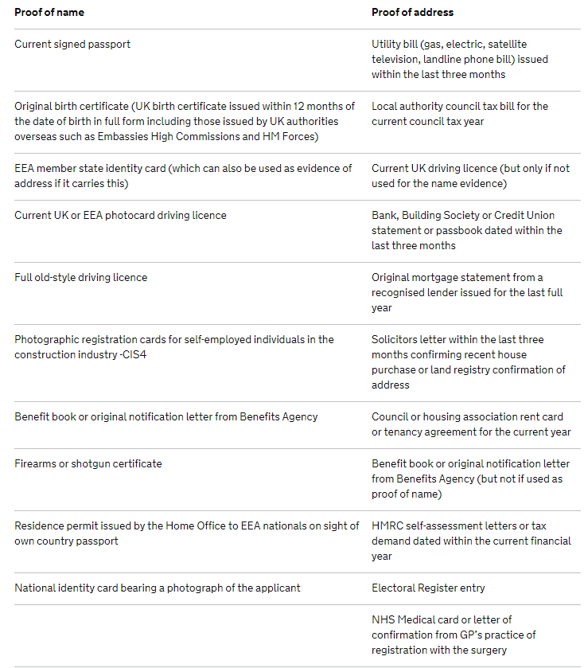

**Appendix B Privacy Notice**

(Insert name of charity) Privacy Notice

1. The (insert name of charity) may collect and process the following information in relation to your application:

* Personal identifiers, contacts and characteristics (for example, name and contact details
* Medical Information
* Financial Information
* (Add or delete to this list as appropriate)

1. The personal information processed is provided to us directly by the applicant in order for (name of charity) to be able to offer appropriate accommodation and meet the objects of the charity.
2. The lawful basis that we rely on for processing this information is that the (name of the charity) has a legitimate interest.
3. Your information is securely stored (enter location)
4. We keep interview information for (time period). We will dispose of your information by (explain how you will delete their data)

Please contact us at (insert email address, phone number and/or postal address) if you wish further information.