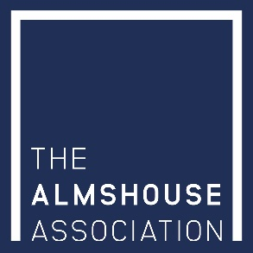

Registered Charity No : 245668
The Almshouse Association, Billingbear Lodge, Maidenhead Road, Wokingham, Berks RG40 5RU

ASSOCIATE MEMBERSHIP

I would like to become an Associate Member (Friend) of The Almshouse Association at one of the following levels:

Annual Subscription - £100 per annum ……..
or (Please tick as appropriate)
Lifetime Membership - a one-off donation of £500 ……..

Please complete in BLOCK CAPITALS:

Name : ………………………………………………………

Address : ………………………………………………………

………………………………………………………

Post Code ……………………………………

Daytime Tel. No. : ……………………………………………………. Email: ……………………………………………

□ I have made payment via The Almshouse Association website

□ I have enclosed a cheque for £ ………………. (minimum £100.00)

□ I wish to pay by STANDING ORDER and will instruct my bank accordingly

□ I wish to pay by BACS and will instruct my bank accordingly

*If you are a UK tax payer and making a personal donation, please also complete a Gift Aid donation form that can be found on our website. Gift Aid is a government scheme which will enable The Almshouse Association to reclaim the basic rate tax already paid by the donor on any personal donation.

The bank account details of The Almshouse Association are as follows:

Bank Name : Coutts & Co (St Martin’s Office)
Sort Code: 18-00-02
Account name: THE NATIONAL ASSOCIATION OF ALMSHOUSES, Unrestricted Funds
Account No.: 00568716

Signature: …………………………………………………….. Date: ……………………………………………………..

Thank you for your generous support. Please ensure you send the completed form (and payment if applicable) to the above address.

